Sample input:

**Input:**Your code should read the graph from the file. First lines contains (number of nodes, number of edges), second line contains nodes which are source and sink (source,sink) followed by one edge per line (u,v,capacity in u→v)

**Output**: Produce output to a file which contains max flow in the first line followed by one edge per line showing (u,v, flow in u→v).

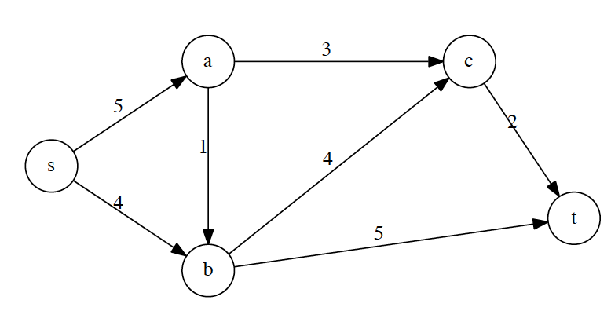

**Sample input:**

(5,7)

(s,t)

(s,a,5)

(s,b,4)

(a,b,1)

(a,c,3)

(b,c,4)

(b,t,5)

(c,t,2)

**Sample output:**

7

(s,a,3)

(s,b,4)

(a,b,1)

(a,c,2)

(b,c,0)

(c,t,2)

(b,t,5)